**Project 1: Exploring Weather Trends**

The aim of this project is to analyse global and local temperature trends, and to compare and contrast the trends between global and local temperatures. This was achieved by visualising data trends and calculating correlation coefficient between both global and local temperatures. This document has 2 main sections: Methods and Results. The Methods Section describes the steps taken to conduct this project. The Results Section describes the results.

**METHODS**

**Data Extraction and Description**

Data was extracted from the database using SQL query:

|  |
| --- |
| SELECT year, city, avg_temp FROM city_data WHERE city = 'Abuja';  SELECT * FROM global_data; |

Global temperature data contained annual average temperatures from 1750 to 2015. The city selected for local temperature trends is Abuja, Nigeria. City dataset contained annual average temperature from 1856 to 2013, with missing values from 1863 to 1872.

**Moving Averages**

MS Excel was used for this step. 10 year moving averages were calculated for both global and local temperatures. The formula used goes as follows:

=AVERAGE(CELL1:CELL2)

(where cell one and two are 10 subsequent cells with the temperature values).

Basically, the average of the last 10 annual temperatures were calculated for each annual temperature.

**Data Visualisation**

MS Excel was used for data visualisation. A Combo line chart with both primary and secondary vertical axes and a primary horizontal axis was used to visualise the temperature trends. Primary and Secondary Vertical Axes were used because the local temperatures were very high compared to the global temperatures, and visualising the trends for both with the same axis did not communicate the trends clearly. Interval unit between labels in the vertical axis was set to 10 to account for the 10-year moving averages.

**Limitations:**

There were missing values in the data set:

1. Abuja annual average temperatures for 1750-1855
2. Abuja Moving average temperatures for 1863 - 1872

For (b) above, average temperature values for the same years in the global average temperature data set were deleted as they were considered too few to affect the overall quality of data and results significantly. Regarding (a) and (b), the Count Values for both global (247) and Abuja (139) (Table 1) suggest high variation in the number of missing values for the two variables.

**RESULTS**

**Figure 1: Line Chart of Global vs Abuja Temperature (10-year Moving Average)**

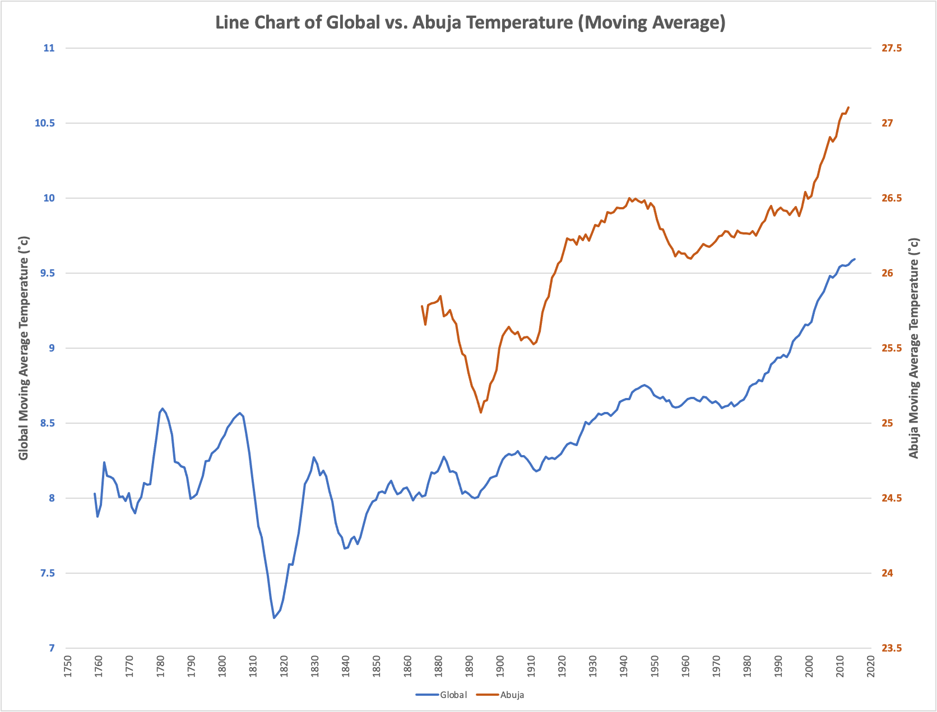

**Descriptive Statistics of Global and Abuja Temperature (10-year Moving Averages)** Table 1: Descriptive Statistics

|  |  |  |
| --- | --- | --- |
|  | *Abuja* | *Global* |
|  |  |  |
| Mean | 26.1 | 8.4 |
| Standard Error | 0.04 | 0.03 |
| Median | 26.2 | 8.3 |
| Mode | 25.6 | 8.2 |
| Standard Deviation | 0.4 | 0.5 |
| Sample Variance | 0.19 | 0.21 |
| Range | 2.0 | 2.4 |
| Minimum | 25.1 | 7.2 |
| Maximum | 27.1 | 9.6 |
| Count | 139.0 | 247.0 |

A standard deviation of 0.44 (Abuja) and 0.46 (Global) suggests that data for both global and Abuja moving average temperatures are close to the mean of the moving average, suggesting less variability in annual average temperatures across the years. The mean moving average temperatures in Abuja is ~26.1˚c, significantly higher than the mean of the global moving average temperatures (~8.4˚c)

Based on the data made available, temperatures in Abuja are significantly higher (between 25.1˚c - 27.1˚c) on average compared to the global average temperatures (between 7.2˚c - 9.6˚c), and the difference has been mostly consistent over time.

**Correlation:**

Table 2: Correlation Coefficient

|  |  |  |  |
| --- | --- | --- | --- |
|  | *Year* | *Abuja* | *Global* |
| Year | 1.00 |  |  |
| Abuja | 0.83 | 1.00 |  |
| Global | 0.75 | 0.90 | 1.00 |

From Table 1, the correlation coefficient between Global 10-year moving average temperature and Abuja 10-year moving average temperature is ~0.90, suggesting a positive correlation. This shows a statistically significant positive relationship between both variables. This implies that where global temperatures increase, temperatures in Abuja also increase.

**Observations:**

Global temperatures and temperatures in Abuja have gradually increased over the years. However, between years, there has been some fluctuations in temperature changes. Also, both locally and globally, increases in temperature became more rapid in the 1980s and the temperatures achieved are significantly higher than those before the 1980s. For global average temperatures, there was a significant cooling in the early 1800s, while in Abuja, this type of cooling occurred in the late 1800s. However, the global average temperatures appear to be cooler.

The graph suggests that the world is getting hotter, generally. However, the differences between temperatures in Abuja and global average temperatures suggest that different world regions may be experiencing this increased temperature differently. This will however need further analysis, and consideration for average temperatures in regions. In the last century, the trends in temperature increase have been generally more rapid than in previous centuries. In addition, the second half of the last 100 years showed higher temperatures than the first half.